1) Configure Classic Load balancer.

* First you need to create Two instances.
* Here one is httpd server and second one is nginx server.
* Here I am taken two instance with diff service’s like httpd and nginx.
* Two understand the traffic.

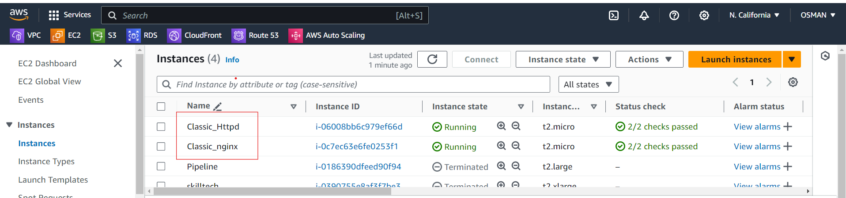

The below img is nginx server.

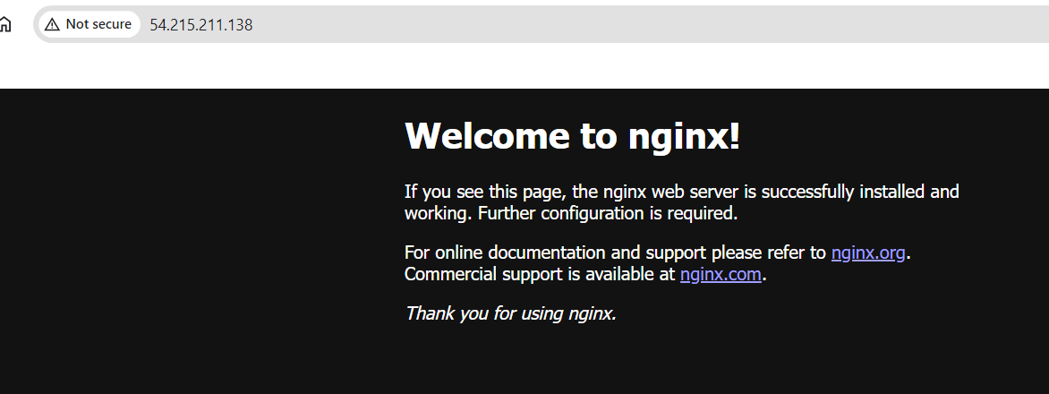

The below img is httpd server

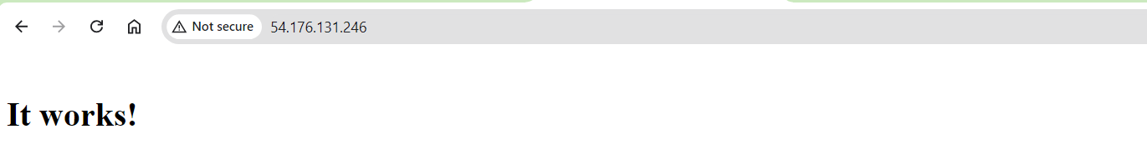

Our servers are ready. Now I am going to the Load balancers and click on create loadbalcer and select the classic loadbalancer.

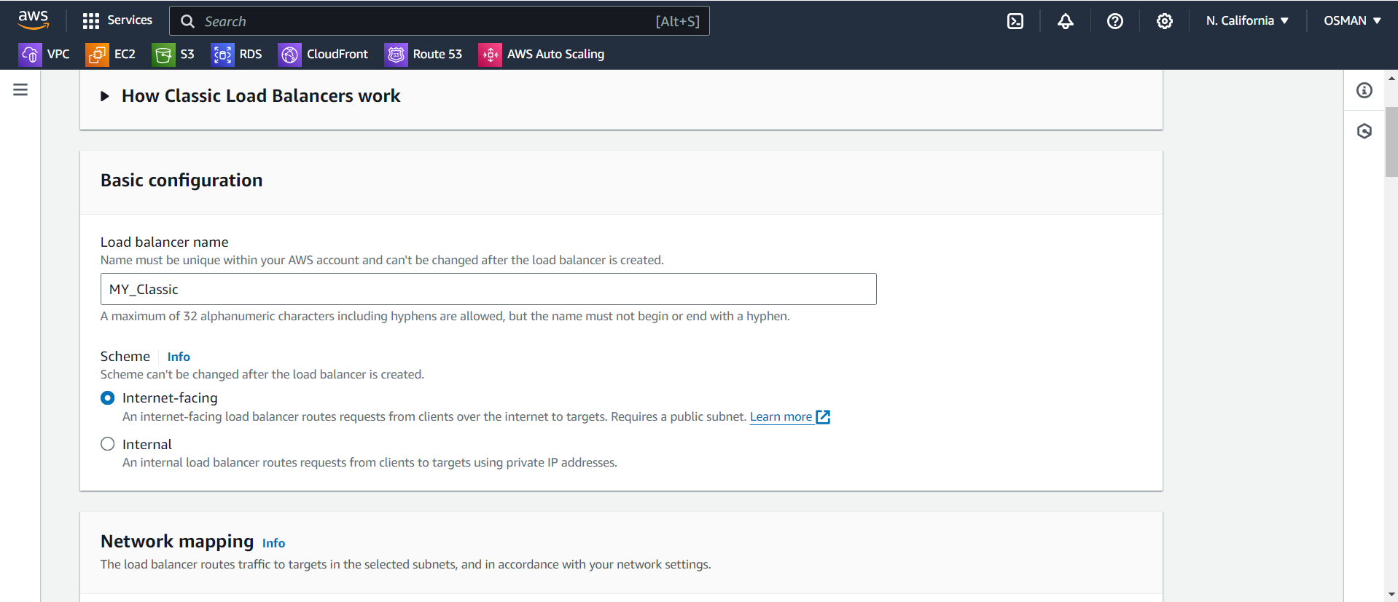

Select you VPC and AAZ

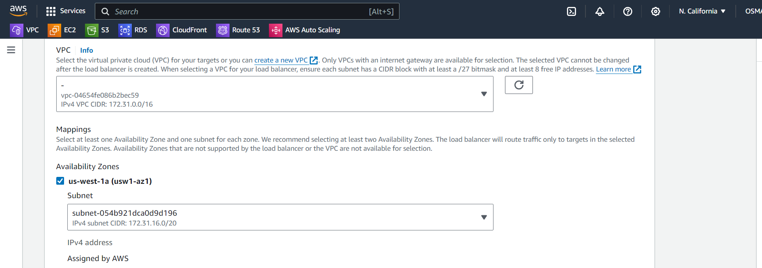

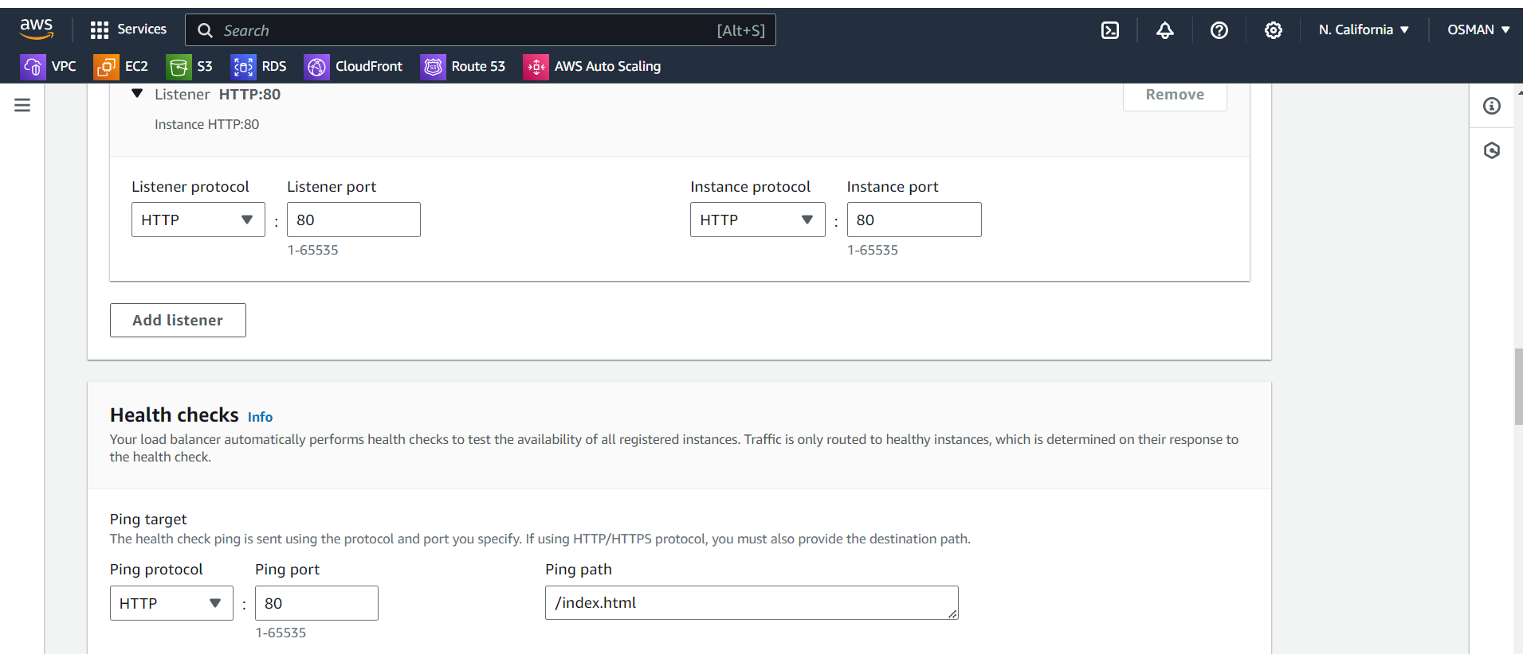

Here iam selecting the two instances.

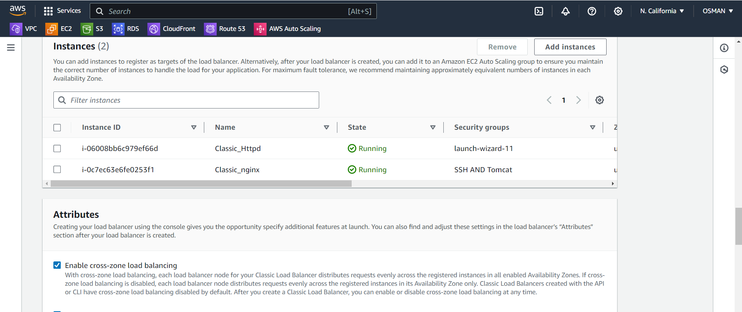

Click on create load balancer.

2) Configure Application Load balancer.

Here I have two instances.

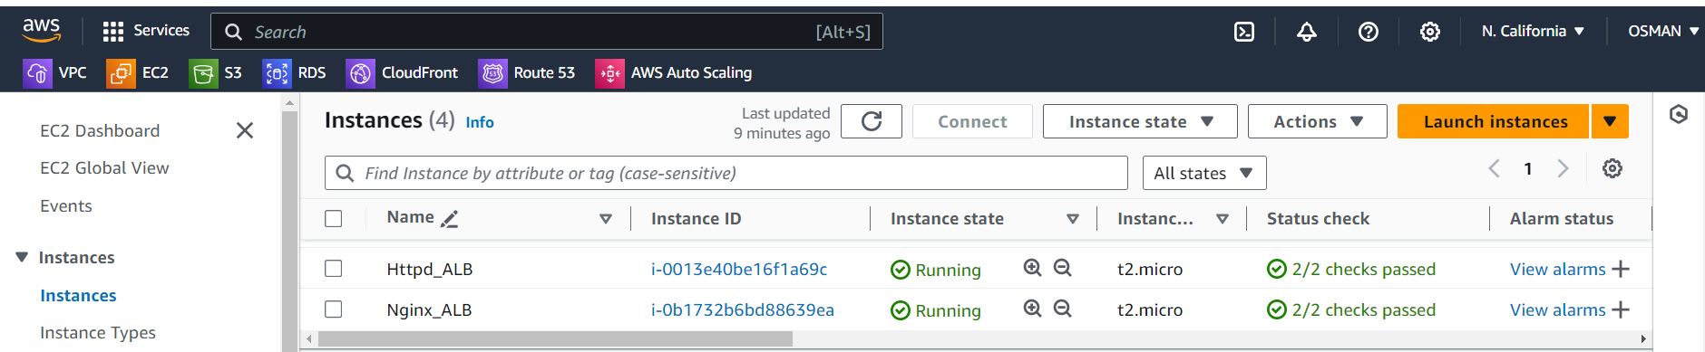

After Go to the Target Groups and create. 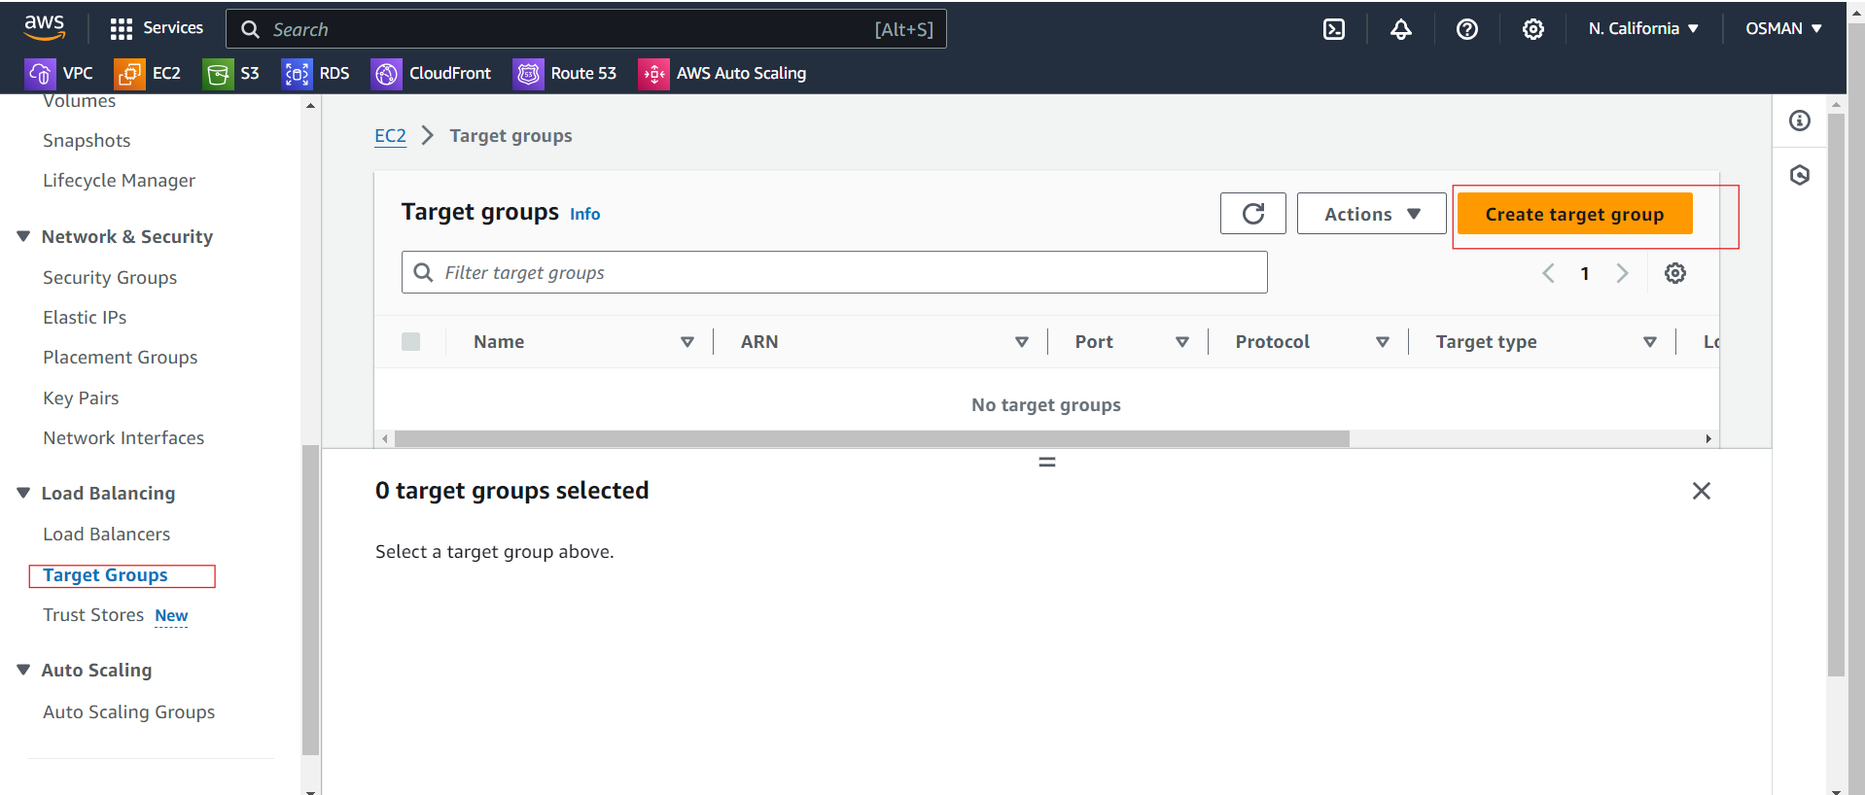

Target type is ---- instances.

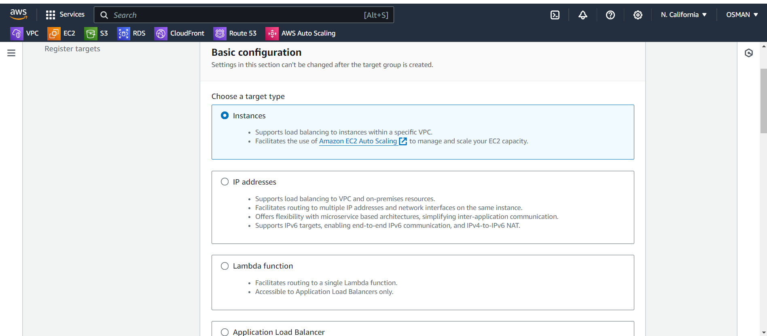

Give target group name and protocal is httpd-80.

Ip address is IpV4.

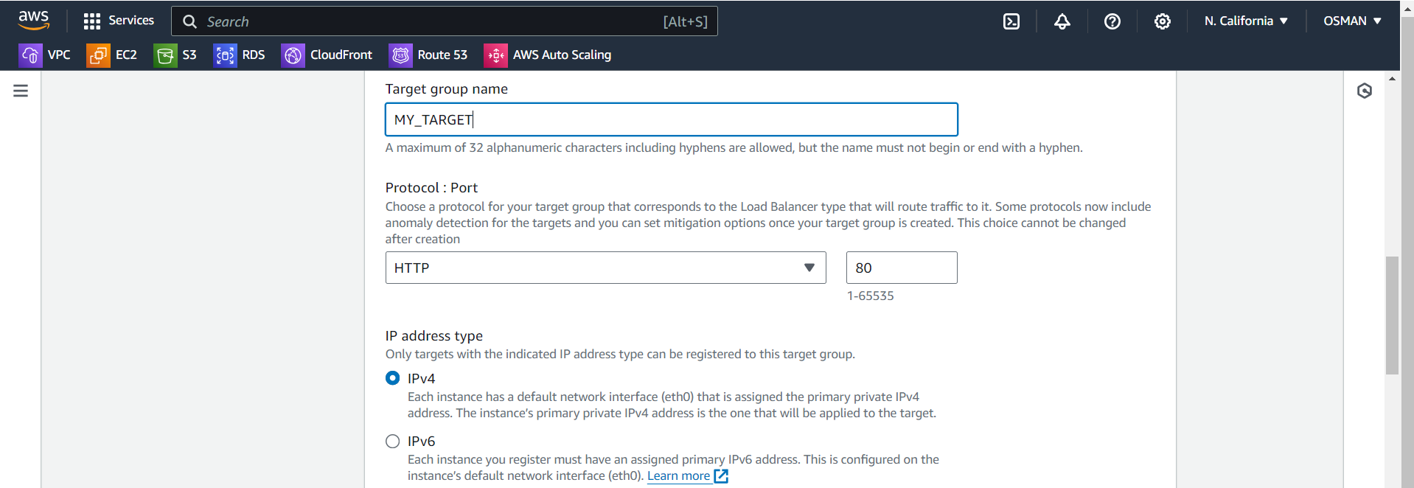

Leave it as it’s and click on Next.

Click on Available instanceses and include as pending below.

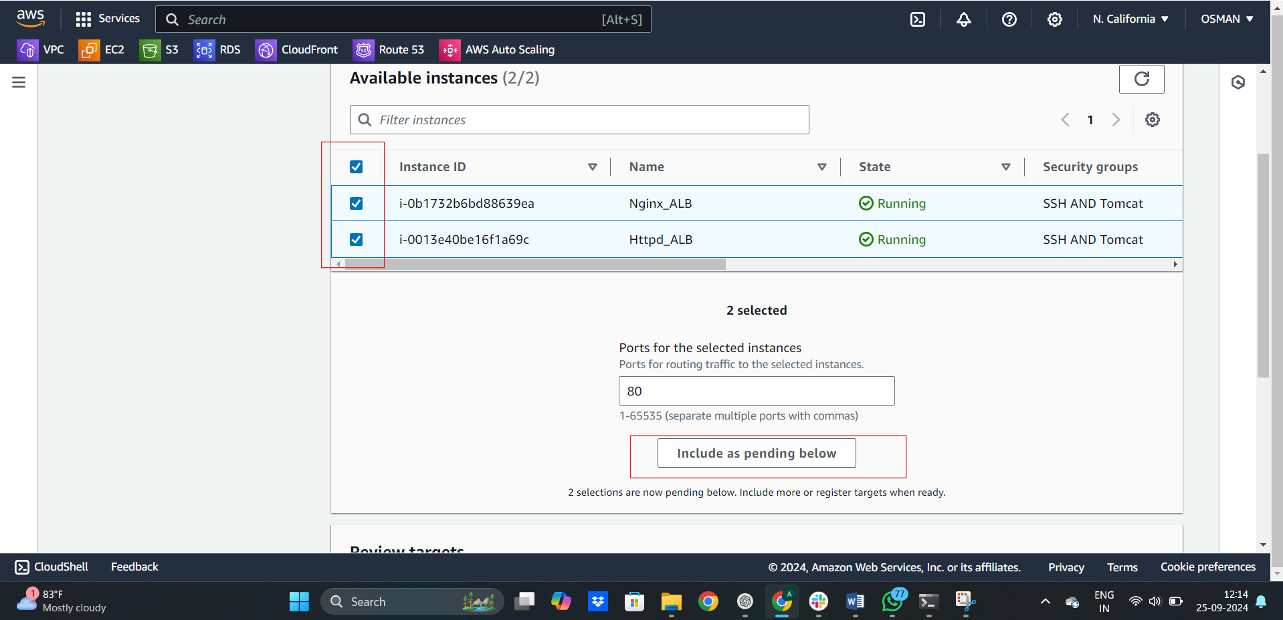

Review the Target groups and click on create target group.

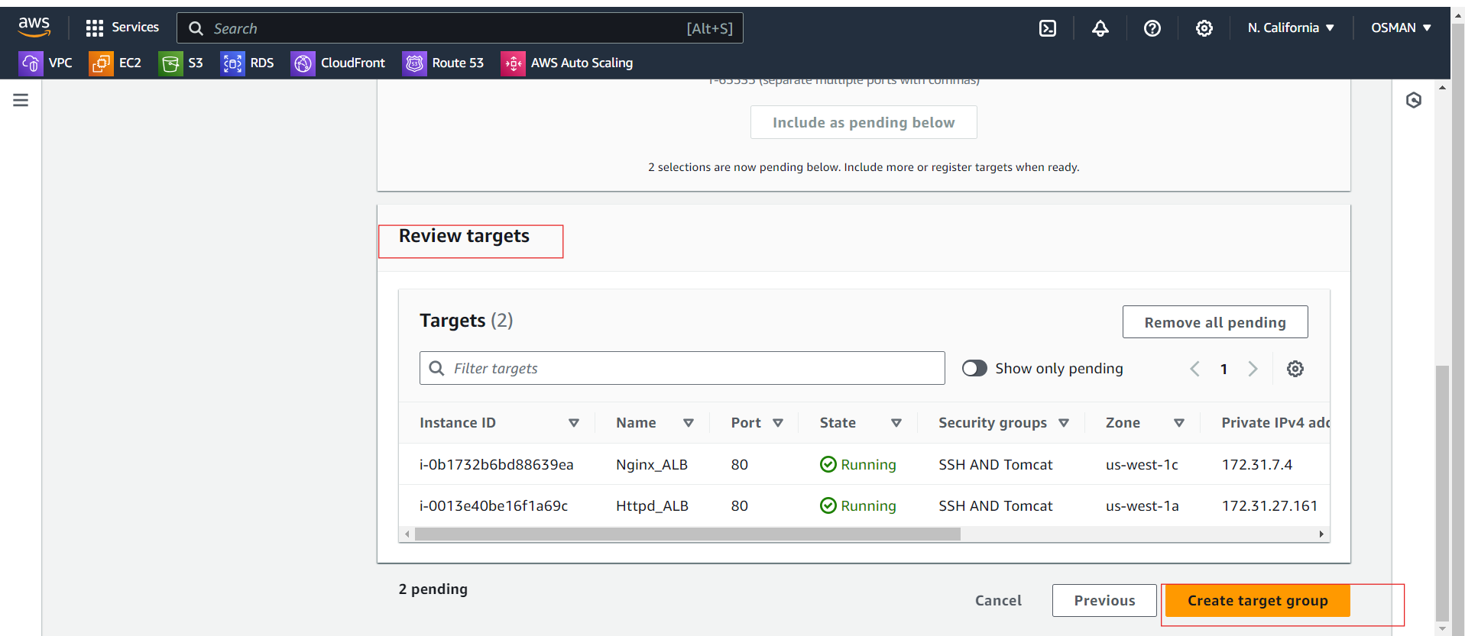

Target group is created.

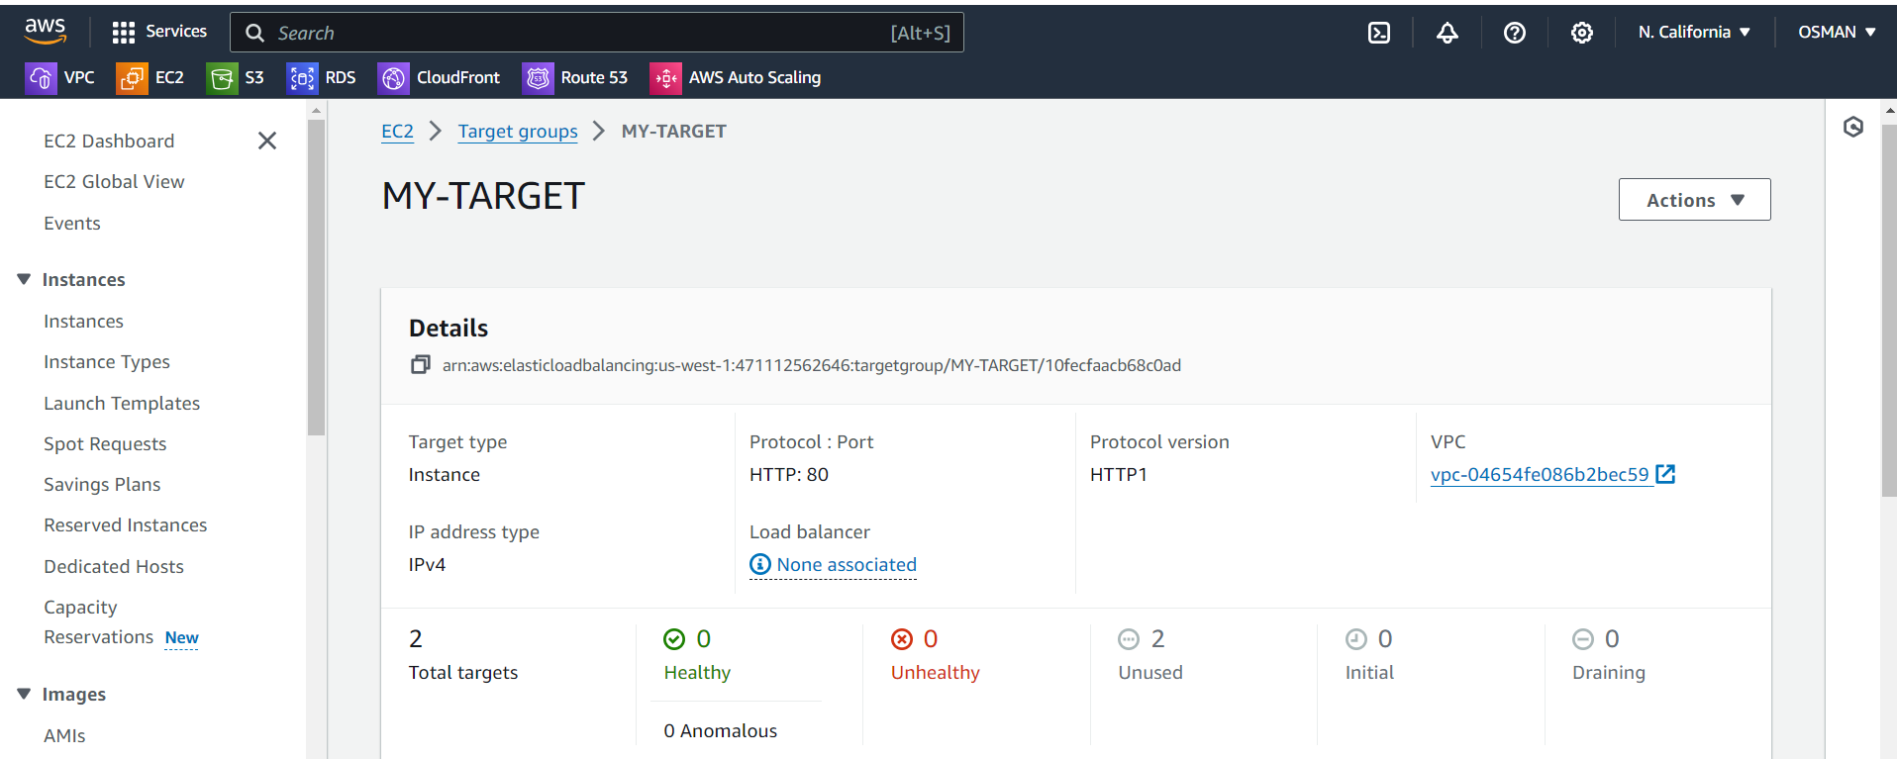

Now we have to Go Load balanceres and create the Application Load balancer.

Give Name and scheme is --- internet Facing

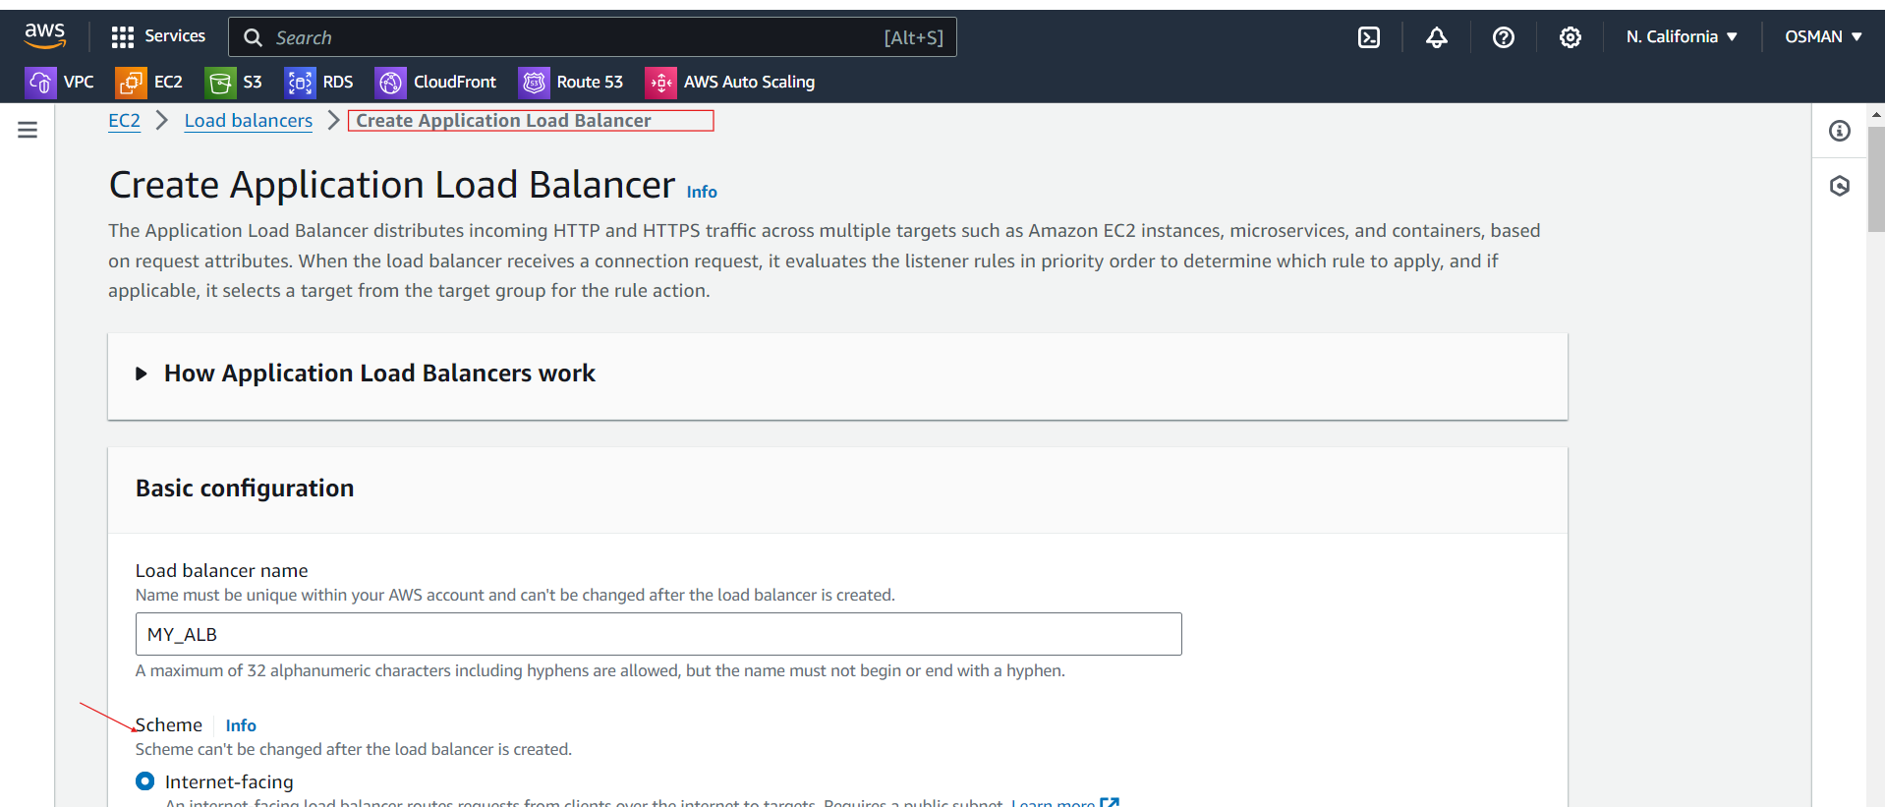

Select--- VPC and Subents.

Must and should give the same VPC, Subnet, Secrity gorups all same for EC2 as well as ALB.

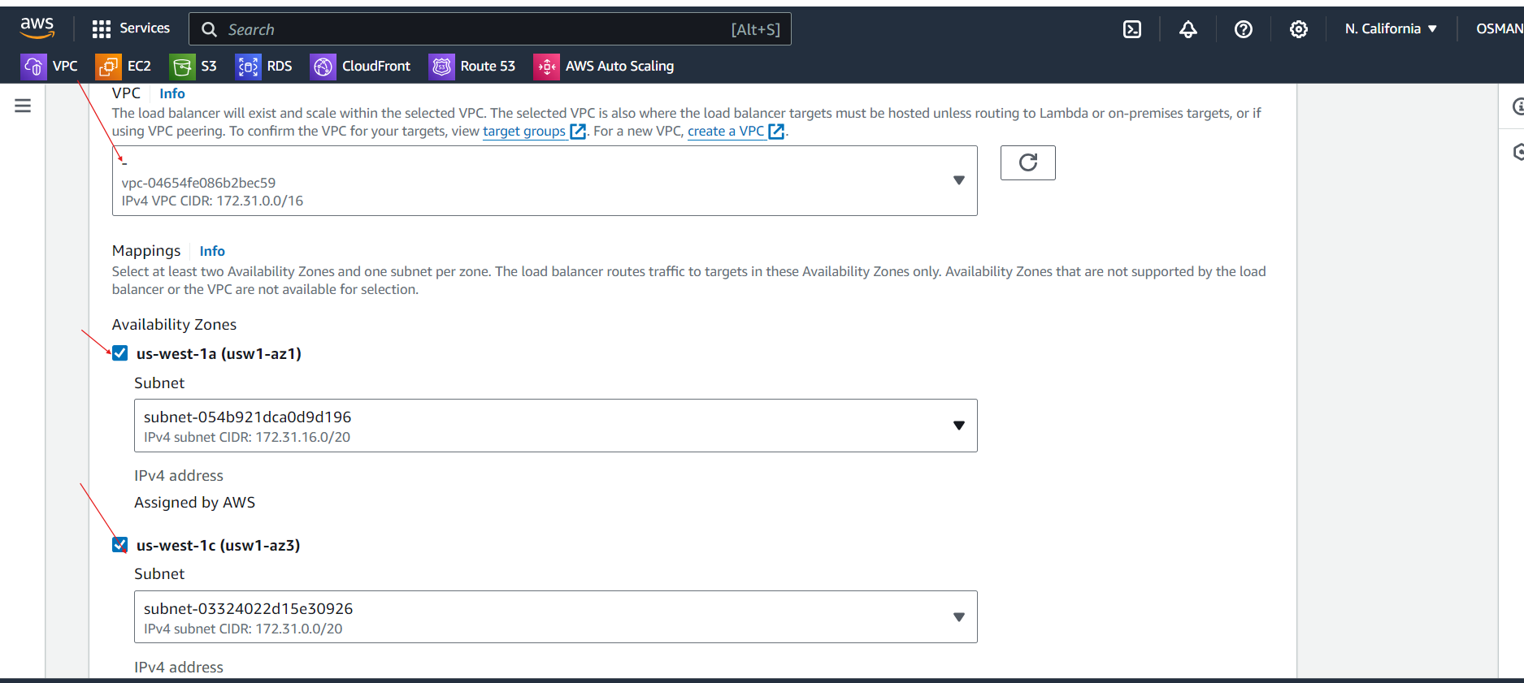

Select the taget groups and click on create ALB.

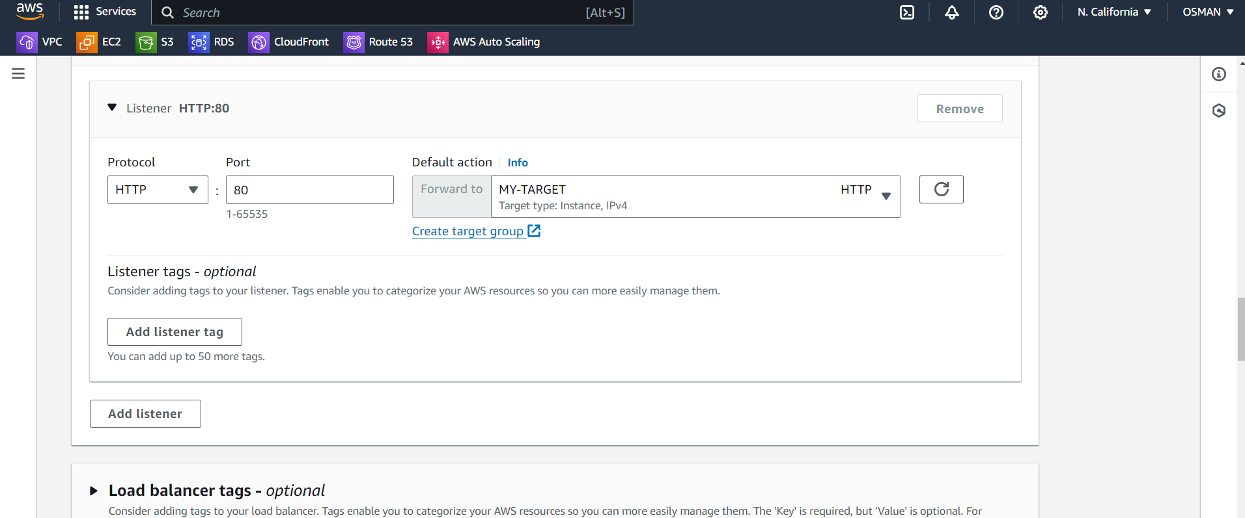

Copy the DNS name.

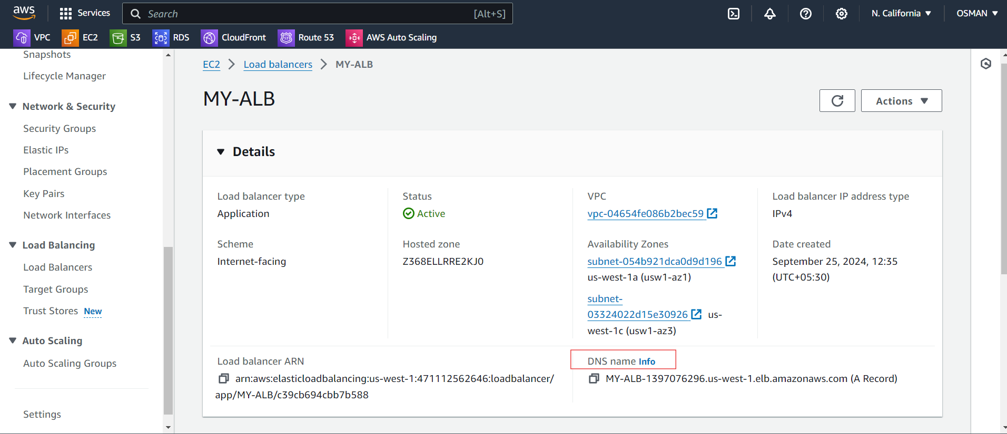

Paste in google chrome .

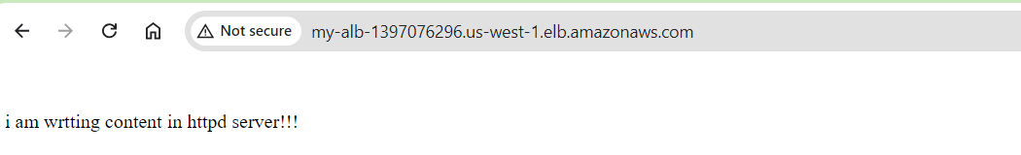

Refresh the google chrome you will see the nginx server page.

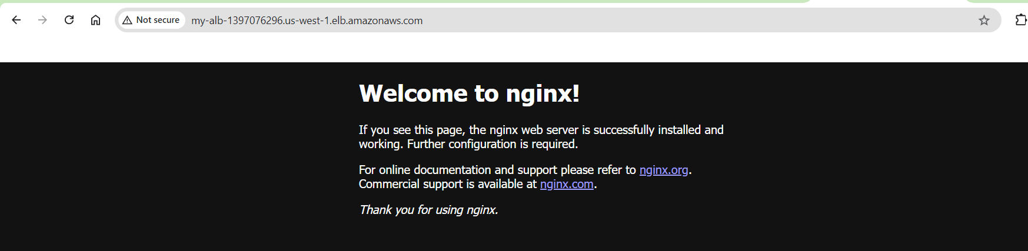

3) Configure Network Load balancer.

* We have already two instances is there and target group.
* But can’t **the same target group** for both an **Application Load Balancer (ALB)** and a **Network Load Balancer (NLB)** directly. This is because ALB operates at the **Layer 7 (HTTP/HTTPS)** of the OSI model, while NLB operates at **Layer 4 (TCP/UDP)**. As a result, the protocol, health check configurations, and target types are different between ALB and NLB.
* So we have to create new target group.
* What we do in creating the ALB-Target group do as it’s but only change is protocal --TCP

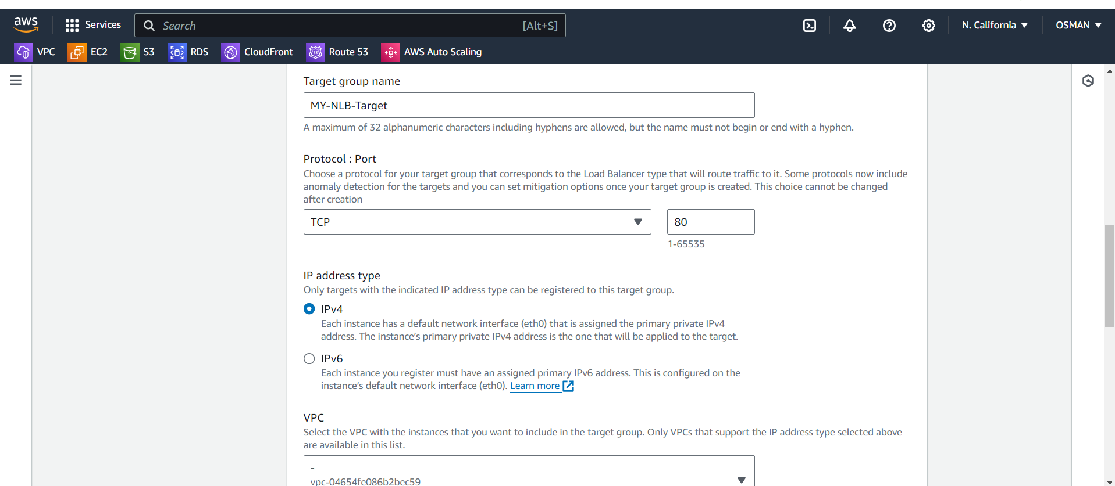

Now we have to configure the Network Load balancer.

Here also only change is protocal is -- TCP

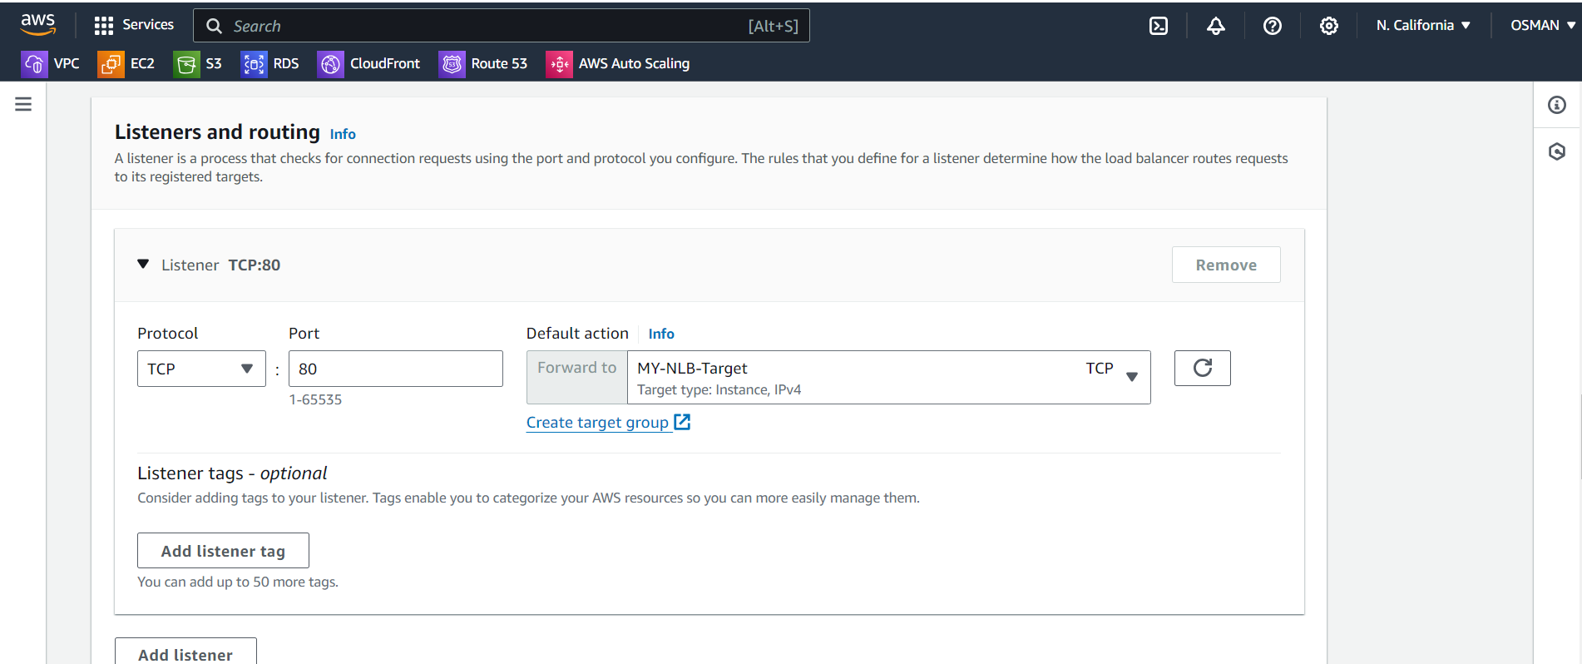

Just click on create Network load balancer.

Now you will see the Load balancer.

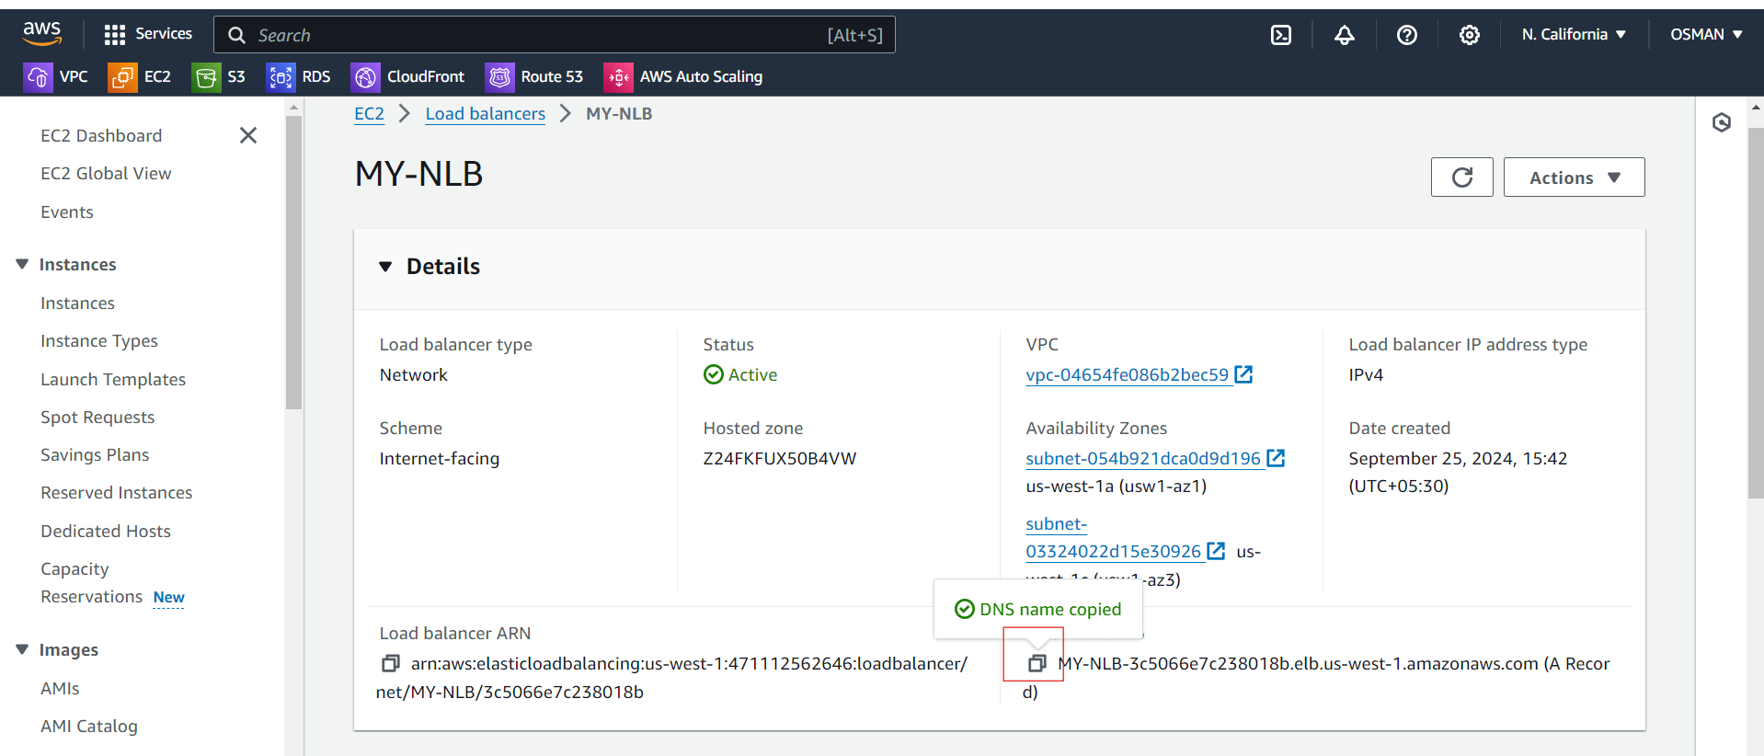

DNS name Paste in google chrome

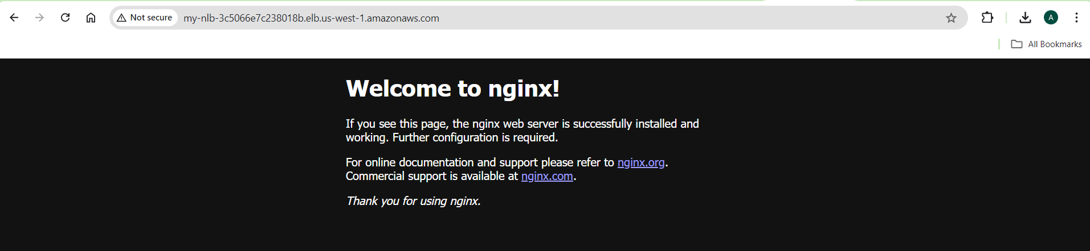

Refresh the google chrome you will see the httpd server index.html file content.

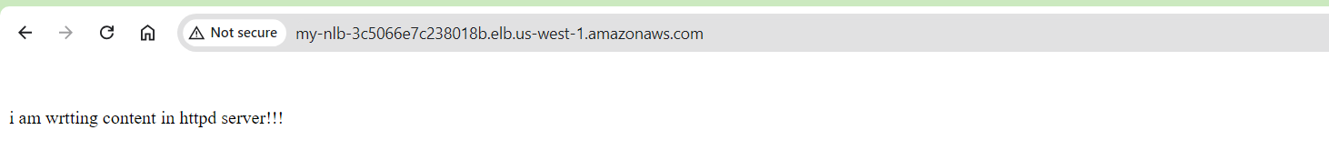

######################

4) Attach SSL for application load balancer.

* To do that first you have ssl certificate.
* To get certificate rise request and get certificate.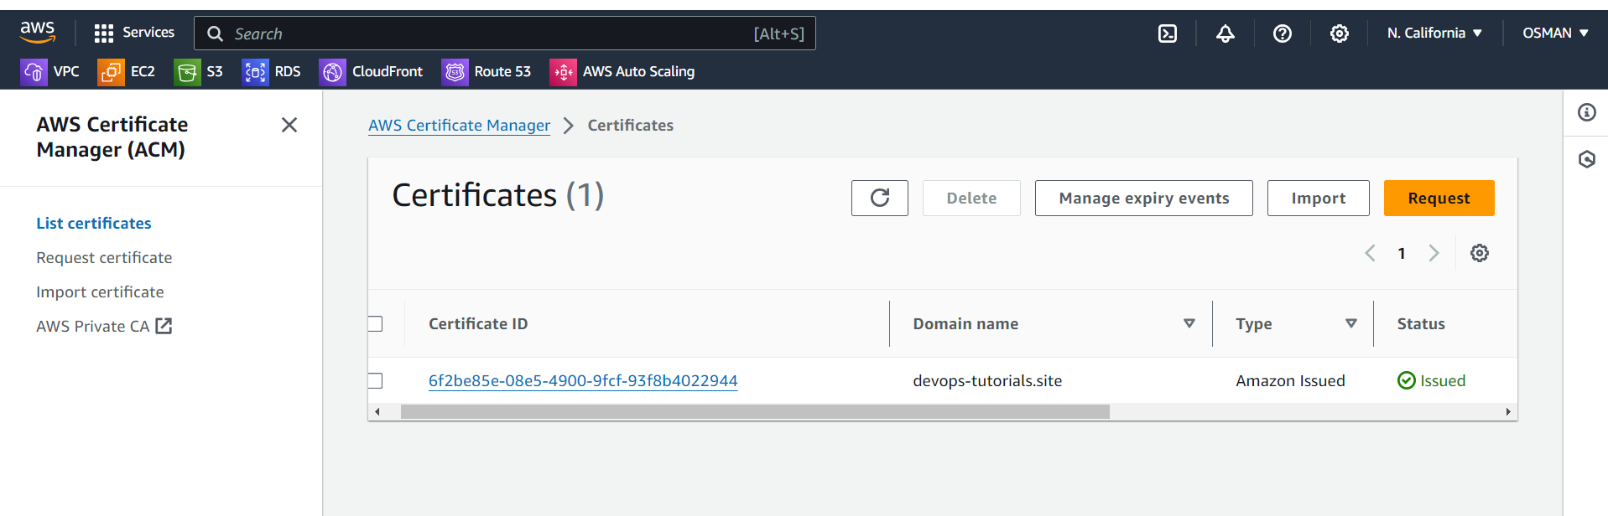
* Then go to the Application load balancer.
* Click on Add Listener

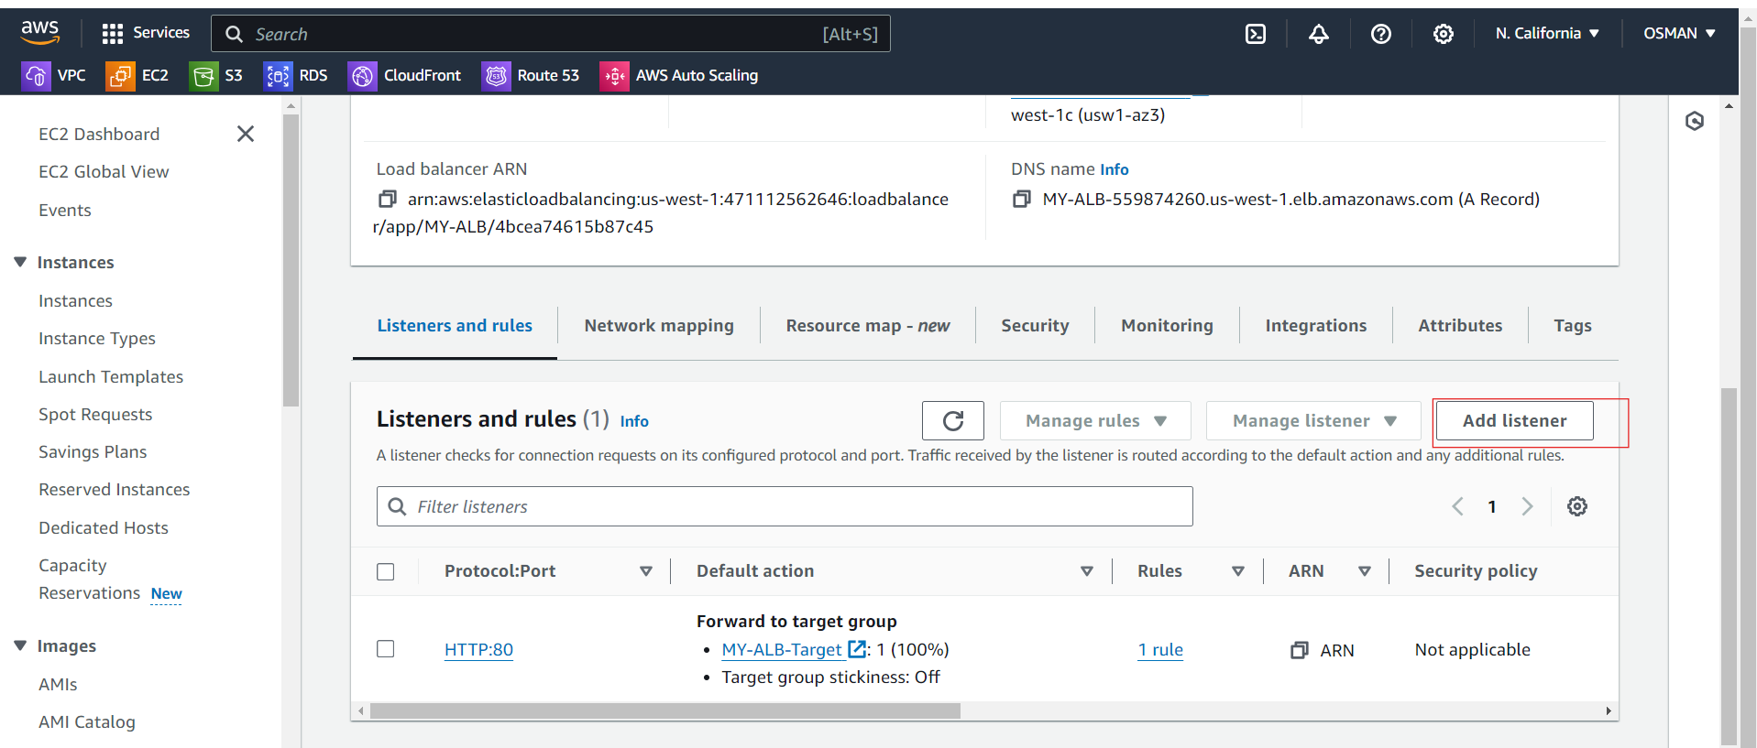

Here change the protocal and select the target Group.

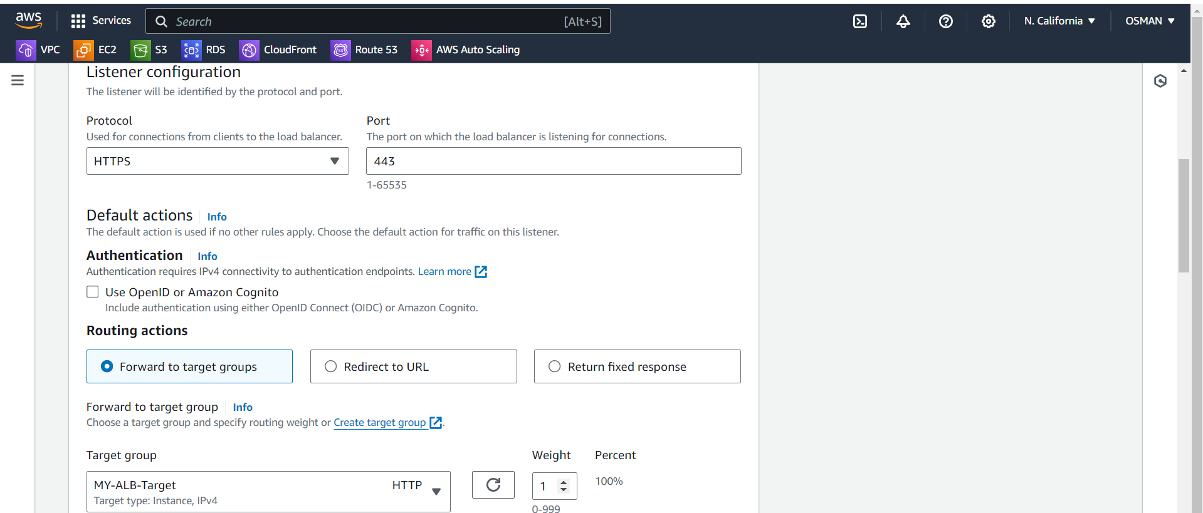

Here you need to attach the ACM certificate.

Click on ADD.

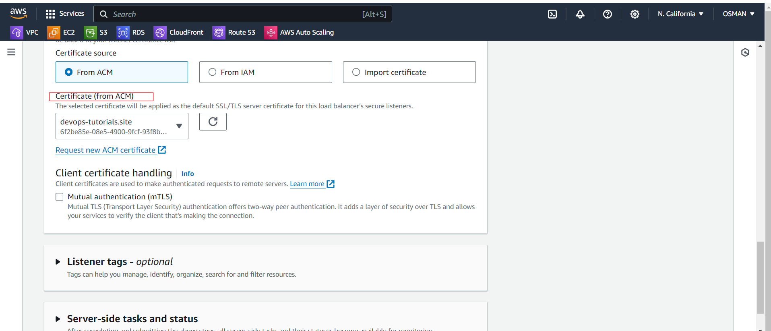Now see ALB Listeners I am added the ssl certificate.

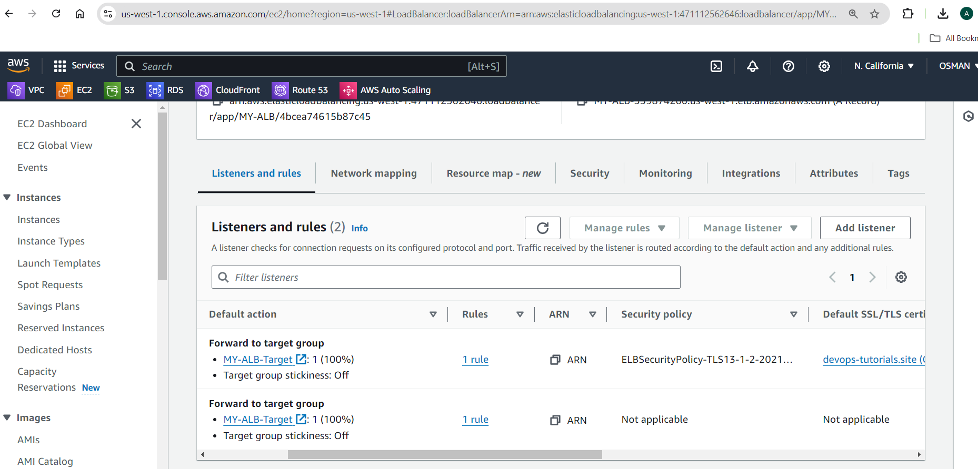

Now copy DNS name and Browse and add https.

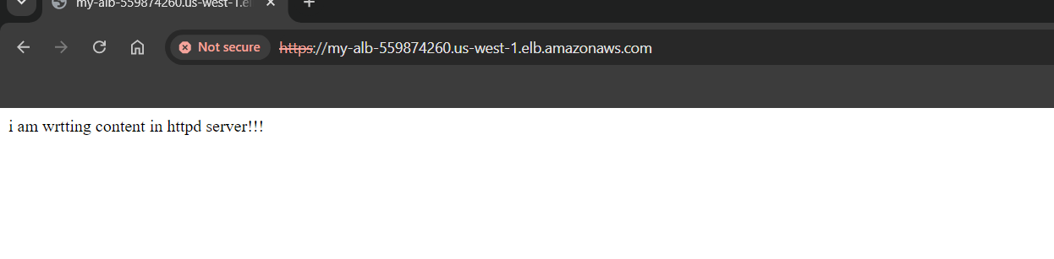

5) Map Applciation load balancer to R53.

* We have Already ALB.
* So we have to go R53 and click on create record.

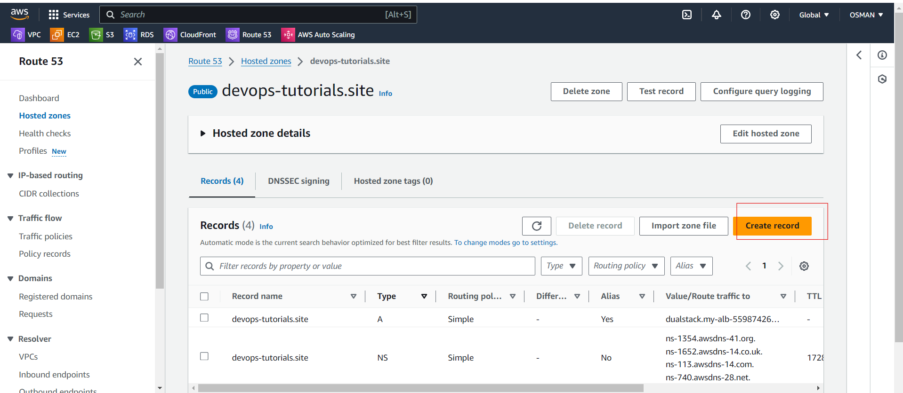

* There you have to click on the --- Alias
* Select – Alias to Application and Classic Load Balancer
* Select --- region
* Select your ALB DSN name.
* Click on create Record.

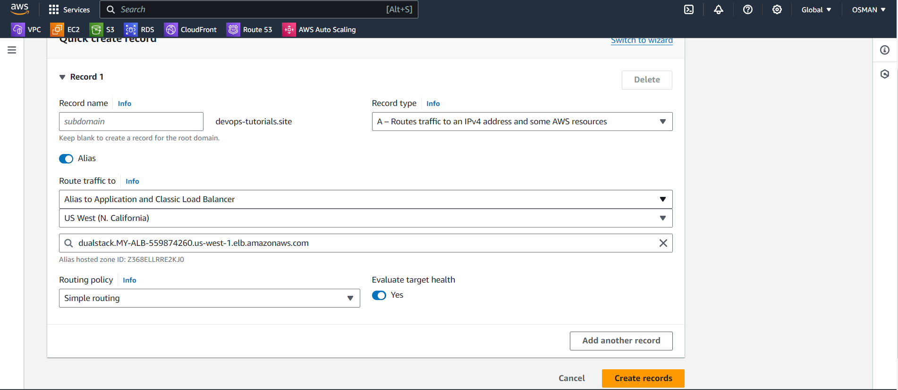

Now One Record created.

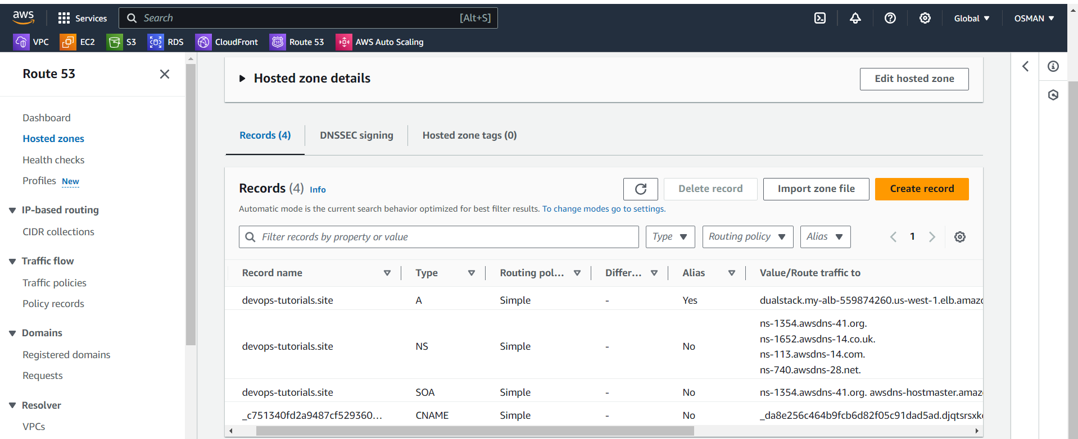

Now you can browse your domain name you will see our application.

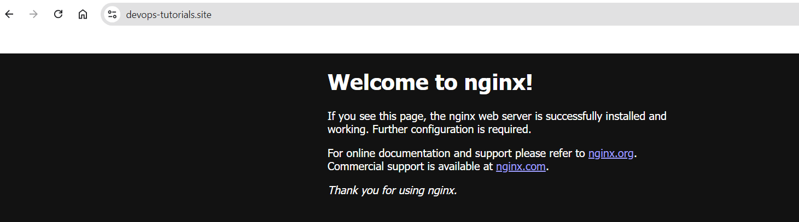



6) Push the application load balancer logs to s3.

Now I am created One s3 with same region of ALB.

Edit the bucket policy and save.

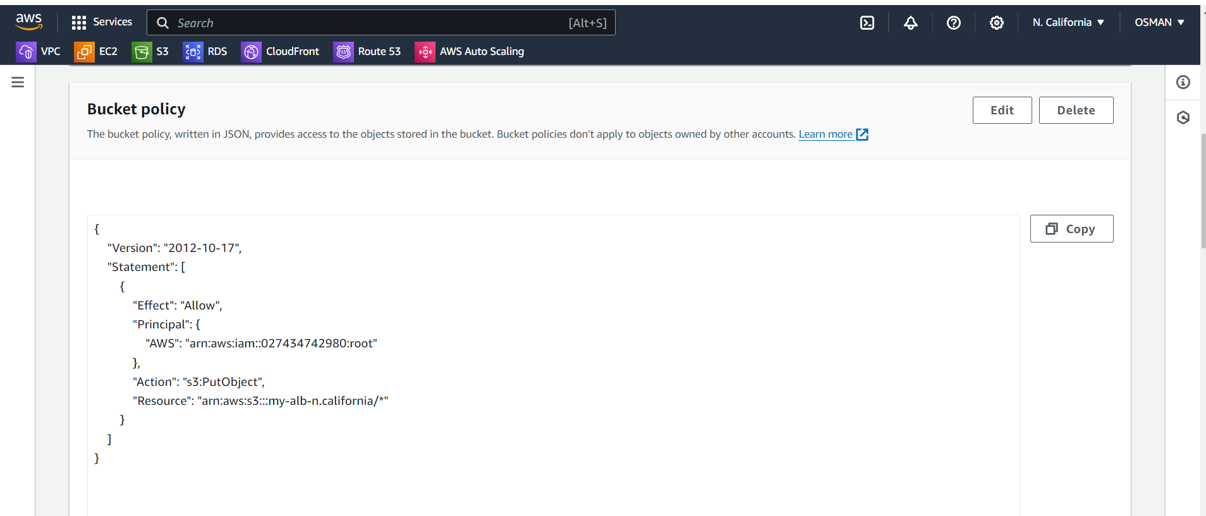 Now I am went to ALB.

GO to Attributes.

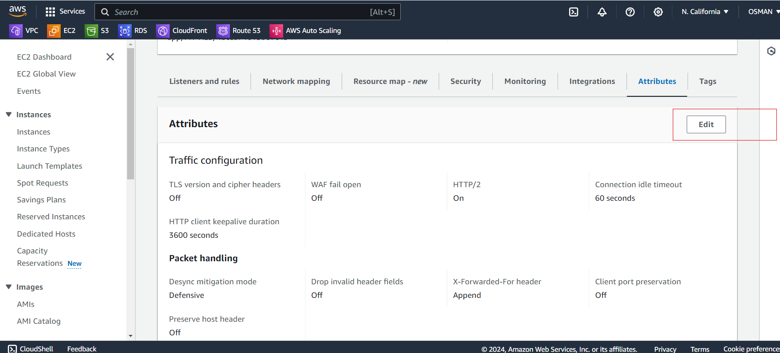

* Enable Access Logs.
* Select the s3 bukets and click on save changes.

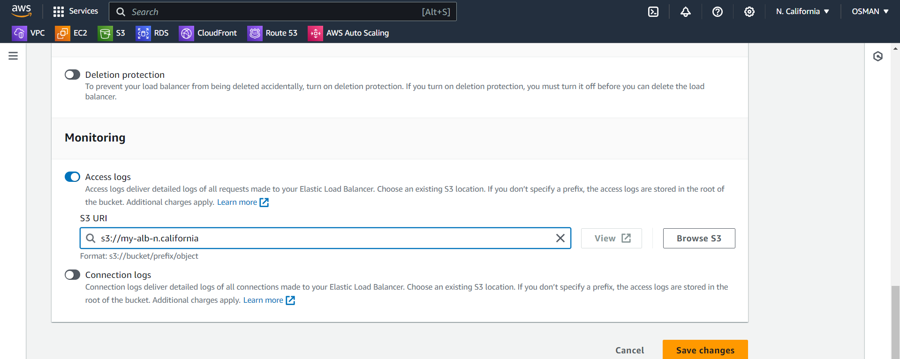

* Now go to the s3 bucket.
* In the bucket you see the logs.

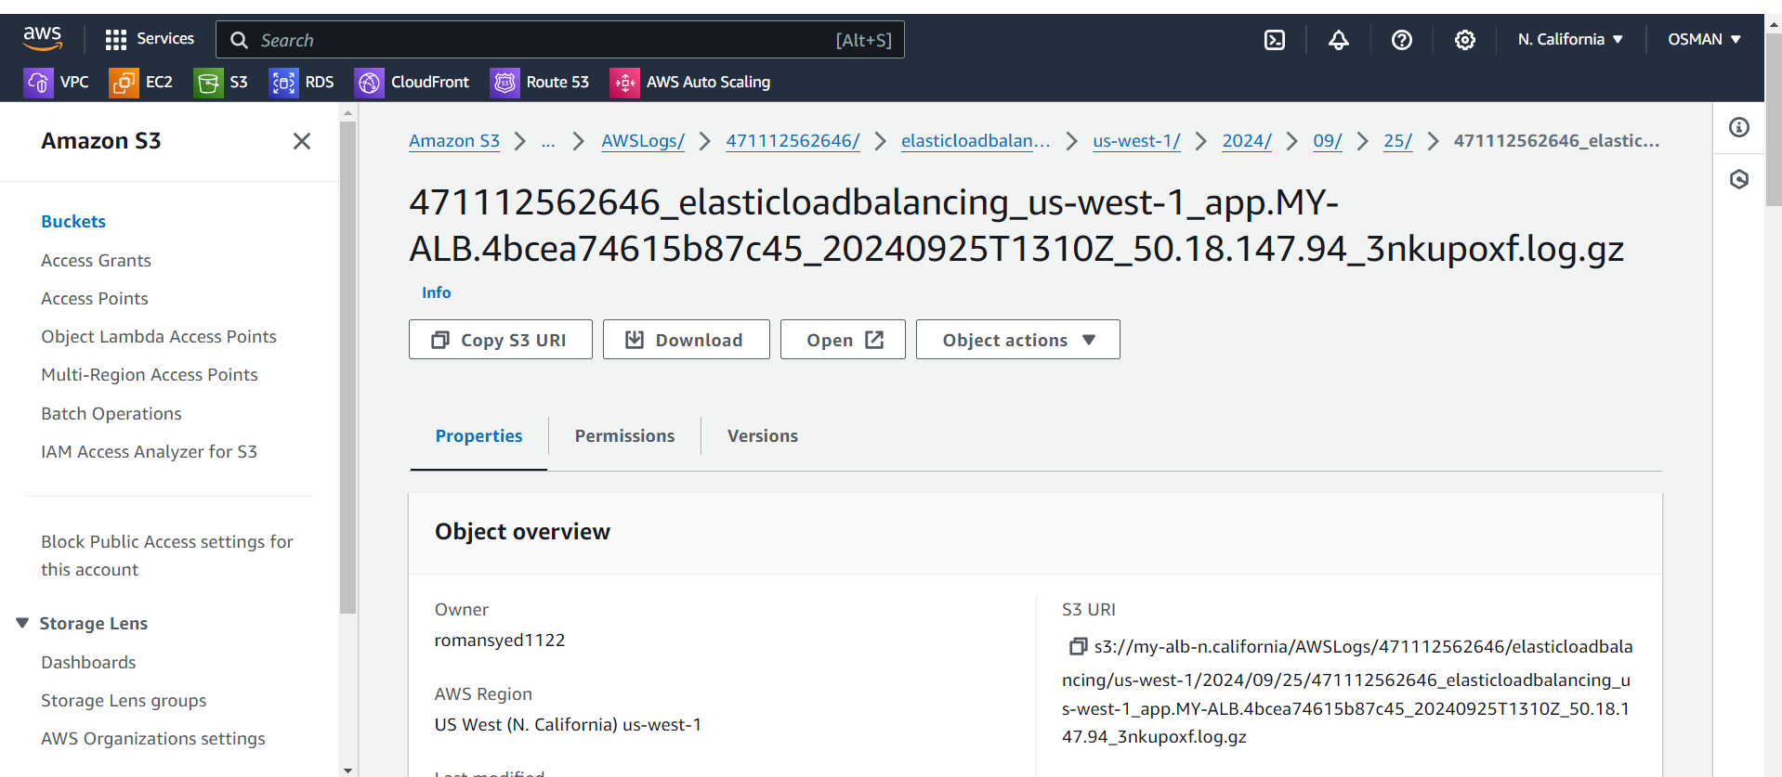

Task is Done.

########################